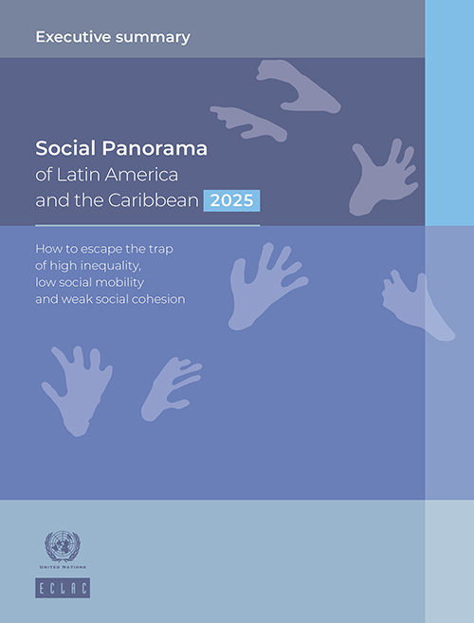 | Statistical Annex  Social Panorama of Latin America and the Caribbean 2025
In the statistical annex of the Social Panorama of Latin America and the Caribbean 2025 you can directly access 26 selected indicators on poverty, income distribution, education, employment and labor income. Through the different links provided for each indicator, you can access the information in different ways:

- Graph: with this modality a graph is displayed that can be customized by adding or deleting series and categories, and whose data can be extracted in XML, JSON or XLSX format.
- Geoportal: the indicator is displayed on a map of Latin American and Caribbean countries. The map is customizable and layers with new indicators can be added or removed, among other modifications. One of the options allows you to switch to the graphic system and download the information in XML, JSON or XLSX format.
- Table generator: allows access to a selection board of various categories for which you can disaggregate the selected indicator and generate a multiple entry table with the PIVOT option, downloadable in XML, JSON or XLSX format, or a table in flat format with the FLAT (TIDY) option, also downloadable in the mentioned formats.
- Download in flat format: allows a direct download (with a single click) of the indicator data in flat format in an Excel file.

Indicator | Graph | Geoportal | Table generator |  | Download in flat format
Population living in extreme poverty and poverty, by area |  |  |  | 
Value of extreme poverty and poverty lines
Population living in extreme poverty and poverty, by highest level of education attained, sex and area
Femininity index for extreme poverty and poverty, by area
Population living in extreme poverty and poverty, by age group, gender and area

Indicator | Graph |  | Geoportal | Table generator |  | Download in flat format
Population living in extreme poverty and poverty, by ethno-racial self-identification, sex and area
Population living in poverty, by major administrative division
Population living in extreme poverty, by major administrative division

Indicator | Graph |  | Geoportal |  | Table Generator | Download in flat format
Household income distribution, by deciles and area
Ratio of median income between quintile 5 and quintile 1
Gini income concentration index
Population with income below different percentages of the median, by area

Indicator | Graph | Geoportal | Table Generator | Download in flat format
School attendance, by age group, quintiles, and area
Population aged 20 to 24 years with complete secondary education, by gender and area

Indicator | Graph | Geoportal | Table Generator | Download in flat format
Labor force participation rate, by sex, age group and area
Labor force participation rate, by level of education, gender and area
Distribution of the employed population by type of labor market insertion and sex
Indicator | Graph | Geoportal | Table Generator | Download in flat format
Urban population employed in low productivity jobs, by sex
Employed population affiliated to a social security system, by sex, quintiles and area
Employed population contributing to a pension system, by sex, quintiles and area
Open unemployment rate in urban areas, by age group and sex
Open unemployment rate, by quintiles and sex

Indicator | Graph |  | Geoportal | Table Generator |  | Download in flat format
Average income of the employed population, by labor market insertion and sex
Ratio of median income between women and men, by age group and area
Ratio of average income between women and men, by years of education and area
Average income of the urban employed population in low-productivity jobs, by sex

