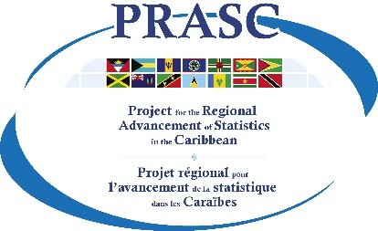 | Template: Open License Agreement  Prepared by Statistics Canada  July 2020  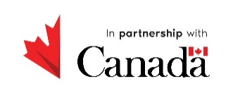

Template – Open Licence Agreement

Open Licence Agreement

This agreement is between the (name of your NSO and country) and you (an individual or a legal entity that you are authorized represent). Your use of the data indicates your acceptance of the terms below.

Definitions

For the purpose of this licence:

"Information" means any data files, data bases, tables, graphs, maps and text for which the (name of your NSO and country) is the owner or a licensee of all intellectual property rights.

“Value-added products” means any products you have produced by adapting or incorporating the data in whole or in part.

Licence grant

The (name of your NSO and country) grants you (an individual or a legal entity that you are authorized to represent) a worldwide, royalty-free non-exclusive licence to freely use the data, copy, modify, translate, publish, adapt, distribute, create derivative works and value- added products for commercial and non-commercial purposes subject to the terms of this licence.

Acknowledgement of source

You shall include and maintain the following notice on all licenced rights of the data and where possible provide a link to this licence.

Source: (name of your NSO and country). Contains information licenced under the (name of your NSO and country)’s Open Licence Agreement.

You shall include and maintain the following notice for all value-added products.

This product was adapted from the (name of your NSO and country)’s information, which is licenced under the (name of your NSO and country)’s Open Licence Agreement.

Limitation

The licence provided herein is limited solely to (name of your NSO and country) data and shall not extend to any third party data, software, and source code. All third party data downloaded from the (name of your NSO and country)’s website shall be subject to a separate licensing terms identified by the third party.

Intellectual property rights

Intellectual property rights that the (name of your NSO and country) may have in the data shall remain the property of the (name of your NSO and country). Intellectual property rights that third parties may have in the data shall remain their property. Intellectual property rights in valued-added products, being any and all intellectual property rights recognized by law, shall vest in you.

Term

This agreement is effective as of the date and time you access the information and shall terminate automatically if you breach any of the terms of the licence agreement.

Non-endorsement

This licence does not grant you the right to use the data in a way that suggests an official status or endorsement of you or your use of the data.

Disclaimer

Data are made available “as is” without warranty of any kind, including the implied warranties or merchantability and fitness for a particular purpose. The (name of your NSO and country)will not be held responsible for damages resulting from its use or interpretation including any consequential damages, punitive damages, direct or indirect damages or loss of profits.

Applicable law

The agreement shall be governed and construed in accordance with the laws of (name of your country).

