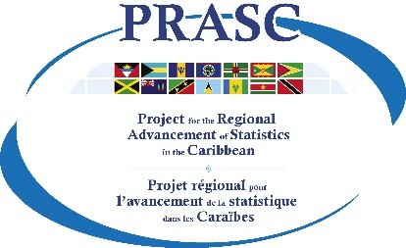



2020 PHC Round
Dissemination Plan

TEMPLATE
Prepared by Statistics Canada
November 2022
Insert NSO Name
202x Population and Housing Census
Dissemination Plan
Contents
Purpose 3
Background 3
Objectives 3
Strategic considerations 4
Users and Uses of census data 4
Dissemination approach 5
Overall dissemination plan and timeline 6
Product Templates / Common-look-and-feel / Standards 7
Software & Tools 7
Budget 7
Evaluation 7

Purpose
Short text outlining the purpose of this document. Here is an example.
Dissemination can be viewed as a project within the Census Programme. This Dissemination Plan is a tool to obtain commitment from all affected groups and individuals associated with Census Dissemination whether working directly on dissemination or on other census elements that interact with dissemination. It is a communication vehicle that can – and should – be referenced throughout the dissemination project.
This plan describes the project’s organization and outlines the deliverables, the process for creating them and the schedule for their production.

Background
Short text outlining the context within which the dissemination work will take place. Examples of items to note include the following:
- Dissemination in past censuses
- Outline of current census methodology; very brief
- Directly related census elements and the nature of their interaction with dissemination: e.g. analysis, communications, processing, quality management
- Support from outside the NSO; e.g. . key stakeholder consultations, technical support, analytic support
- Context of NSO dissemination strategies and policies in general
- NSO strategic priorities that may influence the census dissemination project
- May want to cross reference to overall census planning document(s)

Objectives
Short text noting the mandate of the dissemination project and highlighting major objectives. Here is an example.
The mandate of the dissemination project is getting relevant census statistical information into the hands of users in a timely fashion and ensuring they have the tools to use and understand it. Major objectives include:
- Timely release of outputs according to published release schedule
- Full use of Internet as the primary means of product release
- Varied and modern set of products that are relevant for user needs and free of errors
- Interpretability: readily accessible metadata on methods and concepts
- Accessibility: facilitate user defined tabulations using REDATAM or similar product
- Promote the use of census data (in collaboration with Communications)

Strategic considerations
Identify strategic considerations, such as:
- key concerns related to the dissemination of the 202x Population and Housing Census products. (e.g. new methodologies, sensitive topics, new user needs, external factors like elections or public debates)
- key needs of major users of census data and analytic outputs – from consultations
- national and regional requirements for data dissemination
- How to achieve timeliness within resources available? – what strategies to take? Basic products, level of disaggregation, level of geography… (to be then reflected in the timeline and release calendar and product types)
- What will be the primary vehicle of dissemination? E.g. Website/online

Users and Uses of census data
Identify major users and uses of census data and analytic outputs. Identify their specific needs. Refer to target audiences and segmentation in the census communication plan to line up. This is a means of segmenting the target audiences for census outputs and will assist in identifying and developing relevant products to meet the needs of users.
Here is a diagram which illustrates the kind of segmentation to consider.
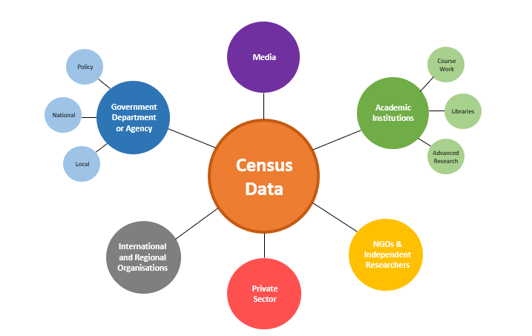

Dissemination approach
Describe the general dissemination strategy & approach and how the dissemination objectives will be achieved. If a phased dissemination approach is used, include topics, sub-topics and type of products by phase.

Types of products
Identify the range of product types you expect or plan to use in the dissemination program. Examples of major product classes include:

- Census overview and glossary of terms
- Press releases
- Thematic reports - providing basic statistics and simple analyses by topic – also includes cross reference to related metadata
- Analytic reports - providing more in depth and/or cross-cutting analyses – also includes cross reference to related metadata
- Infographics & infobytes
- User defined data tables (pre-set tables on NSO website and/or user-defined tables via REDATAM)
At a more detailed level these products may include some of the following example elements:
- Thematic maps
- Comparative data from other sources
- Outline of methodology
- Definitions of key concepts and variables
- Outline of context
- Discussion of analysis
- Highlights of findings
- Other visual products and tools
- REDATAM database and access for creation of user defined tables

Production steps
In a brief stepwise way outline the steps that will be required for each release to proceed from analysis work through to publicly released output products. Amongst others, this may include steps such as the following:
- Establish output objectives (should address NSO’s and stakeholders’ interests/needs) including via consultations with key stakeholders
- Design outputs (subject to overall census requirements and guidelines)
- Certification or validation of database
- Build or enhance products including their validation and quality assessment
- Interpret and explain outputs (interaction with analysis work)
- Apply disclosure control
- Review and approval of products
- Release day activities (including promotion BEFORE and AFTER day of release) – can refer back to the Census communication plan

Overall dissemination plan and timeline
Release by release indicate the topics and sub-topics to be included and the planned date for the release. For each release, indicate the set of products to be made available.
This is the overall plan. It is not required in this document but for each release a more detailed plan and schedule for the required production steps should also be developed.
The following is an example of how an overall plan might start out:

Release 0: Census Overview and glossary of terms
for release at the same time or before release 1
  - Press release
  - Overview and glossary of terms

Release 1: population and dwelling counts; age and sex
6 months after data collection completed
  - Tabulations of Pop and dwelling counts at national and sub-national geographies
  - Thematic report for pop and dwelling
  - Counts by sex and five year age group, national and sub-national geographies
    - REDATAM
    - Tables, graphs, thematic maps (static or interactive)
  - Thematic report for age/sex
  - Infographics and infobytes for both pop and dwelling and age/sex
  - Major highlights for other variables (where feasible given the timeline), national level only
  - Press release

Release 2: next theme
2 months after release 1
  - Tables, charts, graphs as needed and thematic report
  - Infographics and infobytes
  - Highlights report for variables not covered at release 1
  - Press release

Similarly for subsequent thematic releases
Identify any planned in depth analytic reports and the schedule for their release.

Product Templates / Common-look-and-feel / Standards
Short text providing a reference to NSO or Census-specific guidelines and standards for content, structure, look and feel of information products, and Census branding. This may include but is not limited to:
- Standard or recommended structure for
  - Press releases
  - Highlights reports
  - General reports
  - Thematic reports
  - Analytic reports
- Guidelines for narrative style
- formats of tables, charts and graphs; wording of titles; use of colour, indenting, bold, fonts, etc.

Software & Tools
Short text identifying software and related tools by which dissemination will be accomplished.

Budget
Short text on budget allocated and distribution, as required.

Evaluation
Short text. As an element of overall census program evaluation, briefly explain how each release and the dissemination program as a whole will be evaluated. Topics such as but not limited to the following.
- By whom, how and by when the evaluation will be done.
- Aspects of dissemination to be evaluated, such as:
  - Were stated objectives met? Key success factors. Reasons for missed objectives.
  - Unexpected challenges and how they were overcome
  - Performance and effectiveness of software and IT setup
  - Inferences derived from user feedback
  - Lessons learned and recommendations for the future

