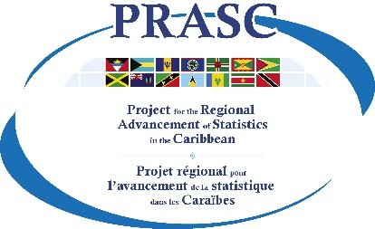 | Template: Introduction Letter to Survey Respondents  Prepared by Statistics Canada  April 2019  

Date

Dear Sir or Madam:
[As a short context, insert one sentence to explain that your office is conducting the xxx survey and that the household or person is selected to participate.]

Your participation is important
[Include a short sentence indicating that participation is important and that it could or will benefit the community.]

Results from this survey will be used to:

[Explain the benefits of the survey. Use 2 or 3 examples (not more) as concrete as possible.]

- Example 1 [Could it have an impact on development of certain programs for the population, like job training or education program?]
- Example 2 [Create support programs and inform the acquisition of development aid.]
- Example 3 [Can you think of anything else? If not, don’t worry about it. Two examples is ok too!]

[Be careful with the examples. Don’t over promise things that cannot be delivered.]

Participating is easy and secure
- [Indicate how and when the interview will be conducted (example: within the next few weeks, an employee will visit you at home to conduct a short interview.]
- [Explain what enforces the privacy and confidentiality of the data (example: Statistics Act, data collectors made a sworn of secrecy).]

Participation in the LFS is mandatory [when the survey is mandatory]
[Shortly explain under what act or policy the survey is mandatory. If there is enough space insert a quick sentence to reinforce that you will keep their data confidential. ]

For more information
[Insert address or link of your account, if any]
[Insert address or link of your account, if any]
[Insert address or link of your account if you posted your video on YouTube.]

[Also insert Website address (if any), other social media accounts info and/or email address or phone nb to reach your office (only if suitable for you. Also, if you insert contact info like email or phone nb, you have to make sure that you have the resources to answer or reply to questions or information request you may receive).]

[Insert a short thank you.]

[Insert electronic signature of the most appropriate person]
End of letter

Other tips

- Keep your letter as short as possible and on one page only. Focus on the key messages (how it could benefit the people and privacy/confidentiality.

- Have your logo on it. It is part of your branding.

- Use headings. If you have a slogan, you could use it instead of the heading “Your participation is important”

- Use simple words. Any documents for respondents, including letters, must be easy to understand. You are talking to every person living in your country, not to statisticians or data users.

- Use a font and a font size that are easily readable. Arial size 11 is a good option.

- The use of bullets also helps the letter to be easily readable.

- If you can, you could have this letter translated into other languages to reach your population that speak other languages in your country.

