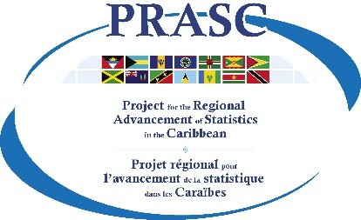 | Template: Website Terms and Conditions  Prepared by Statistics Canada  July 2020  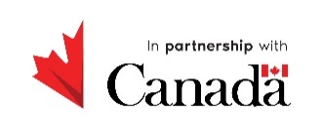

Template - Website Terms and Conditions

Terms and Conditions

General
- This website is owned and operated by the (name of the NSO and Country) (hereinafter referred to as “NSO”).
- By accessing the NSO’s website (“this website”), you unconditionally accept to be legally bound by these Terms and Conditions. If you do not agree to these Terms and Conditions, please do not use this website.
- In case of any violation of these rules and regulations, the NSO reserves the right to seek all remedies available by law and in equity for such violations. These Terms and Conditions apply to all visits to this website, both now and in the future.

Proprietary rights
The materials located on this website, including the information as well as any software programs available on or through this website (“the contents”), are protected by copyright, trademark and other forms of proprietary rights. All rights, title and interest in the contents are owned by, licensed to or controlled by the NSO.
The design and layout of this website is protected by intellectual property and other laws and may not be copied or imitated in whole or in part. No logo, graphic, sound, image or search engine from this website may be copied or transmitted unless expressly permitted by the NSO.

Terms of Use of Data

Access and use of the data is subject to the requirements set forth under the Open Licence Agreement.

Hyperlinks to third party sites
- This website contains hyperlinks to web sites which are not maintained nor controlled by the NSO. The NSO shall not be responsible for the content of any hyperlinked website or any hyperlink contained in a hyperlinked web site, and shall not be liable for any damages or loss arising from access to those websites. Use of the hyperlinks and access to such hyperlinked websites are entirely at your own risk.
- All hyperlinks to other websites are provided as a convenience to you as a user of this website. The inclusion of any hyperlink does not imply endorsement by the NSO of such websites.

Hyperlinks to this website from third party websites
Under no circumstances shall the NSO be considered to be associated with or affiliated in any manner with any trade or service marks, logos, insignia or other devices used or appearing on websites that link to this website or any of the contents.
Questions or comments
If you have any questions or comments, please contact us.

