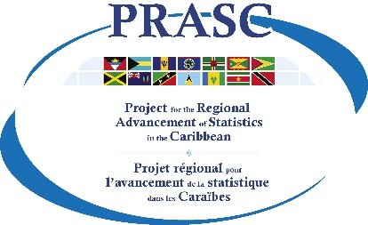 |  | Information Management: Tools and templates  Business Survey Infrastructure Component  October 2021

IM Action Plan

Theme | Challenges | Solutions / Best practices | Activities | Priority

